GUEST INTAKE & INFORMED CONSENT
First & Last Name: Date:

Address: City: ___State:_______Zip: _______
Phone:(home) (cell) DOB:
E-mail: Occupation:
Emergency Contact Name: Phone:
Who can we thank for your visit today?
MEDICAL HISTORY
Bruise Easily | Yes | No | Frequent Anxiety | Yes | No | Frequent Headaches | Yes | No
Herniated Disc | Yes | No | Muscle Spasms | Yes | No | Spinal Injury | Yes | No
Rash/ Inflammation | Yes | No | Keloid Scarring | Yes | No | Pinched Nerve | Yes | No
Thyroid Problems | Yes | No | Diabetes | Yes | No | Arthritis / Joint Deformity | Yes | No
Eczema/ Psorisias | Yes | No | Epilepsy/ Seizures | Yes | No | Low Blood Pressure | Yes | No
Herpes /Cold Sores | Yes | No | Asthma | Yes | No | High Blood Pressure | Yes | No
Autoimmune Disease | Yes | No | Dementia | Yes | No | Varicose Veins/ Blood Cots | Yes | No
Contagious Disease | Yes | No | Hepatitis | Yes | No | Heart Attack/ Pacemaker | Yes | No
Systemic Disease | Yes | No | Bleeding Problems | Yes | No | Irregular Heartbeat/ Murmur | Yes | No
Fainting/ Dizzy Spells | Yes | No | Cancer | Yes | No | Cancer Treatments | Yes | No
Do you have now, or have you ever had any of the following diseases or conditions:

If yes to Cancer, please explain cancer &/or treatments:
Any active infections? If yes, please explain:
Are you suffering from an injury? If yes, please explain:
List any other medical conditions:
List any surgeries in the past six (6) months:
List any medications you take regularly:
List all known allergies:
Are you a smoker? Are you currently pregnant or nursing?

Client Signature (Parent/Legal Guardian):
Date:

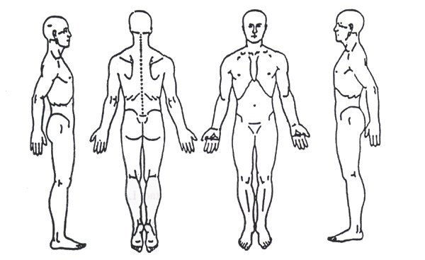
MASSAGE
  - Mark an “X” on areas of the body you want avoided
and CIRCLE areas of the body you want focused on.
  - Draping will be used during every massage.
  - Breast massages will not be performed on female clients.
  - Discuss desired pressure before massage& inform the
therapist during session if you want a different pressure.
What are your expectations for this visit?

I attest the above information is true. I understand that I need to complete this form honestly, disclose all medical conditions affecting me to my Licensed Massage Therapist (LMT). It is my responsibility to keep the LMT updated on my medical conditions. I authorize the releasing and obtaining of information pertaining to my condition(s) &/or my treatment(s) to/from caregivers or third party payers. The treatments I receive are voluntary & I release La Bella & the LMT(s) from liability & assume full responsibilty. I understand that if I’m uncomfortable for any reason, I may ask the LMT to end the session, & the LMT will immedietely end the session. I also understand, that if the LMT is uncomfortable for any reason during the session, the LMTcan immedietly end the session.

Client Signature (Parent/Legal Guardian): Date:
Massage Therapist Signature: Date:
Techniques, pressure, & services used during massage session:
Do you use any products containing Retinol/Vitamin A, Salicylic Acid, or Glycolic Acid?  Are they prescribed by a Doctor?  Have you used any of these products in the last 3 months?  Have you ever had Botox, Dysport, Restylane, Juvederm or other injectables?  In the last month? If yes, please list:  Have you used, or are you on any acne medication (ex: Accutane)? If yes, please list:  Have you ever had laser, microneedling chemical peels, dermaplaning, or microdermabrasion?  In the last month? If yes, please list: | Yes No  Yes No  Yes No  Yes No  Yes No  Yes No  Yes No  Yes No

FACIALS
I understand, have read, & completed this form truthfully. I agree that this constitutes full disclosure, & supersedes any previous verbal or written disclosures. I understand that withholding information or providing misinformation may result in contraindications &/or irritation to the skin. I’m aware it’s my responsibility to inform the facial provider of my current health conditions & keep my medical history updated. The facials I receive are voluntary & I release La Bella & the facial provider from liability & assume full responsibility.
Client Signature (Parent/Legal Guardian): Date:
What skin care products are you currently using? (List brands if known)
Please circle all skin concerns:
Acne/Blackheads/Whiteheads Enlarged pores/Scars Oily Dry/dehydrated Brown Spots/Sun Damage Uneven Texture Rosacea/Redness Sensitive Skin Thin Skin Broken Capillaries Fine Lines/Wrinkles.
Do you have any other problems or skin concerns?

